PRESS RELEASE

COMMUNICATIONS AND MEDIA TEAM OF THE 2023 ASEAN SUMMIT

No.61/SP/TKM-ASEAN2023/ENG/5/2023

Timor-Leste PM Expresses Gratitude for Indonesia's Support

West Manggarai, May 10 2023 –Timor-Leste’s attendance as an observer at the 42nd ASEAN Summit 2023 in Labuan Bajo, East Nusa Tenggara, is a historic moment that will have a positive impact on both the economic and social sectors.

This was emphasized by the Prime Minister of Timor-Leste, Taur Matan Ruak, during the opening of the 42nd ASEAN Summit 2023 at the Meruorah Hotel in West Manggarai, East Nusa Tenggara (NTT) on Wednesday (10/5/2023).

"The participation of Timor-Leste is a historic moment because it can have a positive impact in various sectors, including economic and social. In this way, various developments that have been previously carried out can continue," said Prime Minister Taur Matan Ruak.

The Prime Minister of Timor-Leste also expressed his gratitude for Indonesia's support for Timor-Leste’s accession as a member of ASEAN as well as for the invitation to attend for the first time at the ASEAN Summit and become an observer at the prestigious event in Southeast Asia.

"Thank you to His Excellency Joko Widodo, President of Indonesia and Chair of ASEAN 2023, for his support and commitment thus far, and for giving me an invitation to participate in this historic summit," said PM Taur Matan Ruak.

According to him, it is an honour for his country to attend the ASEAN Summit for the first time, and it is a new chapter in the history of Timor-Leste and ASEAN.

PM Taur also stated that the Timor-Leste government will comply with the follow-up of the Roadmap mutually agreed upon with other ASEAN members.

Previously, President Joko Widodo (Jokowi) congratulated Timor-Leste on joining the ASEAN family during the opening of the 42nd ASEAN Summit in 2023.

At the ASEAN Summit in Phnom Penh in 2022, it was agreed in principle to admit Timor-Leste as a member, which still needed to fulfil certain requirements before becoming a full member. Timor-Leste will be the 11th country to gain membership in ASEAN.

"To the Prime Minister of Timor-Leste, welcome to the ASEAN family," said Indonesian President Joko Widodo.

On the first day of the 42nd ASEAN Summit in 2023, President Joko Widodo is set to chair five meetings, including the ASEAN Summit (Opening and Plenary Session), ASEAN Leaders Interface Meeting with the ASEAN Inter-Parliamentary Assembly (AIPA) Representatives, ASEAN Leaders Interface Meeting with ASEAN Youth Representatives, ASEAN Leaders Interface Meeting with the ASEAN Business Advisory Council (ASEAN-BAC) Representatives, and ASEAN Leaders Interface Meeting with the High-Level Task Force on ASEAN Community's Post-2025 Vision (HLTF-ACV) Representatives.

These five meetings will be concluded by President Joko Widodo in the evening, coinciding with a welcoming dinner at Ayana Komodo Waecicu Beach. (InfoPublik/TR/Elvira)

***

For further information, please contact the following:

Director for Information and Media of the Ministry of Foreign Affairs – Hartyo Harkomoyo (0811831899).

Get more information at http://asean2023.id, https://infopublik.id/kategori/asean-2023, and https://indonesia.go.id/kategori/ragam-asean-2023

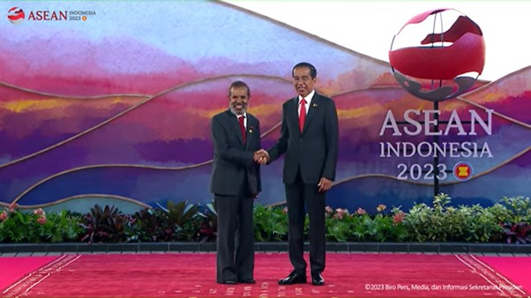

President Joko Widodo (Jokowi) congratulated Timor-Leste on joining the ASEAN family while opening the 42nd ASEAN Summit in 2023. Timor-Leste's Prime Minister, Taur Matan Ruak, emphasized that the 42nd ASEAN Summit in 2023 would be a historic moment that would have a positive impact on the country's economy and social sector. (Photo: BPMI Youtube Screenshot)

